**New research reveals positive evidence that prescribing of antibiotics by GPs is decreasing faster than ever**

***Official NHS Digital data also shows that prescribing for winter colds has reduced significantly***

**For immediate release**

[*Antibiotic Research UK*](http://www.antibioticresearch.org.uk/) *and* [*EXASOL*](http://www.exasol.com/) *release antibiotic prescription data analysis ahead of European Antibiotic Awareness Day on 18th November and The Great British Tea Party – Antibiotic Research UK’s national fundraising event.*

**Key findings include:**

* The national prescribing rate has fallen by over 5% in a year and 11% since the peak in 2012 (reduced from 0.63 antibiotic prescriptions per head of population on average in 2014/2015 to 0.59 in 2015/2016)
* Seasonal variation* has halved in a year from 68% down to 31%, suggesting GPs are heeding advice not to prescribe for winter colds caused by viruses and patients understand that antibiotics are ineffective against viruses
* However, regional variation remains high, with the highest prescribing in the district of Tendring – a district known for high deprivation and an elderly population, both contributing factors
* One antibiotic prescription is still given out every second in England
* Professor Colin Garner, Chief Executive of Antibiotic Research UK hails the research as “hugely encouraging” but warns “there is still much work to be done”

**14 November 2016:** New research by Antibiotic Research UK, the world’s first charity created to develop new antibiotics in the fight against superbugs, and high-performance analytic database company EXASOL, has discovered that antibiotic prescribing is decreasing faster than ever and, crucially, the seasonal variation in prescribing rates has halved in a year. This suggests GPs are heeding advice not to prescribe antibiotics needlessly for winter colds caused by viruses, against which they are ineffective, and patients are not asking for them.

While this is a positive sign, there are still large regional differences throughout the country suggesting that the message to reduce antibiotic prescribing has not reached everyone. Indeed, of the 326 districts in England, 37 districts still recorded an increase in prescribing over the past year.

GP practices in the most deprived parts of the country are still prescribing significantly more antibiotics than the average. Tendring, a district known for high deprivation, an elderly population and home to the most deprived place in the UK (Jaywick), is the highest prescribing district in the country, prescribing 40% more antibiotics than the average.

In contrast, there is real progress in some regions of the country. Three of the districts that were in the top ten highest prescribing in 2014-2015 – Rochdale in Greater Manchester, Halton in Cheshire and Wakefield in West Yorkshire -  recorded double digital percentage decreases in antibiotics prescribing. Overall 14 districts reduced their prescribing by more than ten percent.

To obtain these findings, Antibiotic Research UK and EXASOL analysed data released by NHS Digital. The data includes 6 years of the prescriptions given out by GPs from August 2010 to August 2016 and contains 733 million rows of data. The data was analysed by a data scientist working for EXASOL, using its high performance in-memory analytic database.

Professor Colin Garner, chief executive of Antibiotic Research UK says: “We see the findings as hugely encouraging, a combination of a reduction in prescribing as well as reduced seasonal variation seems to indicate the message is getting through to GP surgeries and we applaud their work in reducing antibiotic prescribing.

“This research also shows how antibiotics are still vital to the general public, with over 32 million antibiotic prescriptions given out in the past year in England, an average of 62 prescriptions a minute or just over one per second. There are signs globally that resistance is increasing so we need more investment to find new antibiotics to ensure they keep working.

“Earlier this year we started our research to find breakers to antibiotic resistance, with the goal of finding a combination of existing therapies that will ‘break’ the resistance that bacteria have built to antibiotics and find a fast solution to the ever-growing problem. Initial findings of this research programme will be released by the end of the year. The charity needs to raise £550,000 in 2017 to fund the next phase of its research.”

Sean Jackson, chief marketing officer (CMO), EXASOL says: “When analysing the data, we can see definitive proof that antibiotics prescribing is finally reducing and that seasonal variation in prescribing is significantly down on last year. However, regionally there are still problems that warrant investigation.

“With the right data and the right technology, you can turn any problem into a data problem and uncover information to help address it. Overuse of antibiotics is still an enormous threat to modern society and by uncovering insights using big data we can see the reality of the problem and take steps to reduce the threat.

“To analyse such enormous data-sets fast, returning answers from the data within seconds, requires the right tool and we hope the findings help to further increase awareness of this serious issue.”

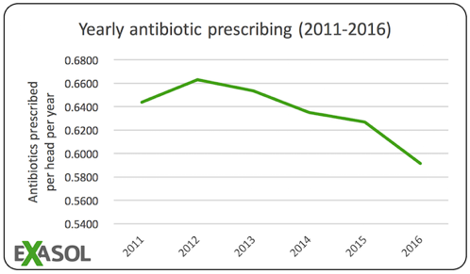

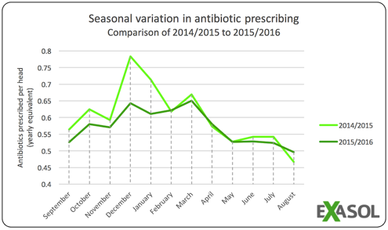

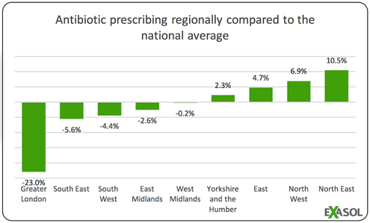

**Notes to Editors**

*Seasonal variation – difference between month with the highest number of prescriptions and the month with the lowest number of prescriptions in a year. Antibiotics prescribing should not vary a huge amount throughout the year. This research looked at the prescribing figures for September 2014-August 2015 and compared them to the data September 2015-August 2016, the most recent data available.

**Data & Images for reproduction**

Link to source data and charts in this press release:

<https://www.dropbox.com/s/a320pqt1cqnak99/antibiotics%20prescribing%20source%20data%20and%20charts.xlsx?dl=1>

<https://www.dropbox.com/s/xv6599wndl82kms/RegionalPrescribing.png?dl=0>

<https://www.dropbox.com/s/lpiqal4whas0kyg/SeasonalVariationinPrescribing.png?dl=0>

<https://www.dropbox.com/s/jo06jt2fakheov5/YearlyPrescribing.png?dl=0>

Heat-maps of prescribing (illustrates regional distribution of antibiotic prescribing)

England:

<https://www.dropbox.com/s/02a2v9kbjxy11tw/AntibioticsPrescribing-England-2011-2012.png?dl=0>

<https://www.dropbox.com/s/pwu83rbo1hyzim8/AntibioticsPrescribing-England-2015-2016.png?dl=0>

<https://www.dropbox.com/s/c3jfseikhdjau4x/AntibioticsPrescribing-England-2011-2012-withPlacenames.png?dl=0>

<https://www.dropbox.com/s/l1u9j2p3jciboug/AntibioticsPrescribing-England-2015-2016-withPlacenames.png?dl=0>

<https://www.dropbox.com/s/nb0lyddsfgx93pj/AntibioticsPrescribing-England-PlacenamesOverlay.png?dl=0>

<https://www.dropbox.com/s/u3ufl9wy9hflepa/AntibioticsPrescribing-England-Legend.png?dl=0>

London:

<https://www.dropbox.com/s/sro4tmht90gljb1/AntibioticsPrescribing-London-2011-2012.png?dl=0>

<https://www.dropbox.com/s/bztypin6hewfai7/AntibioticsPrescribing-London-2015-2016.png?dl=0>

<https://www.dropbox.com/s/8r98oqeol1jkwi4/AntibioticsPrescribing-London-2011-2012-withPlacenames.png?dl=0>

<https://www.dropbox.com/s/e53lxd8t4fr4f01/AntibioticsPrescribing-London-2015-2016-withPlacenames.png?dl=0>

<https://www.dropbox.com/s/3di6m2go3tp391a/AntibioticsPrescribing-London-Legend.png?dl=0>

<https://www.dropbox.com/s/s6jhkf5fm27387s/AntibioticsPrescribing-London-PlacenamesOverlay.png?dl=0>

**List of source datasets used**

Number of patients at a practice by LSOA (July 2016)

<http://content.digital.nhs.uk/catalogue/PUB21150/LSOA-Alt-Format-tall_V2.csv>

Breakdown by GP survey (July 2016)

<http://content.digital.nhs.uk/catalogue/PUB21150/gp-reg-patients-prac-quin-age.csv>

GP Practice Prescribing data (August 2010 – August 2016)

<http://content.digital.nhs.uk/searchcatalogue?q=title:%22presentation+level+data%22&area=&size=10&sort=Relevance>

**About Antibiotic Research UK**

Professor Colin Garner, an academic formerly based at the University of York, founded ANTRUK in June 2014, following discussions held with some of the UK’s leading academic scientists and clinicians who had formed an informal network known as Antibiotic Discovery UK. There was general agreement amongst this community that the country that discovered penicillin and some of the other leading antibiotics in common use today had let this area of drug development slip backwards to such an extent that there was very little research now being conducted in the area.  The charity was registered in July 2014.

In a recent scientific paper by Professor Laura Piddock and her colleague Eilis Bragginton from the University of Birmingham, they estimated that just £95 million was spent on antibiotic research (0.7% of all UK medical research funding). This compares with £500 million spent annually on cancer research and a total annual expenditure on medical research of £1.4 billion.  Without effective antibiotics the position of medicine would go ‘back to the dark ages’ as David Cameron recently stated.

It is against this backdrop that ANTRUK has been created with the aim of developing new antibiotic therapies, educating the public and professionals about the problem and providing patient support to those affected by AMR. The Charity’s mission is to provide a step change in developing new antibiotics with a view to developing one new antibiotic therapy in the next 5-7 years. Typically it takes 10-15 years to develop a new drug but ANTRUK is using some novel methods which short-circuit this process including taking drugs into patients much earlier than currently practiced (accelerating the process of drug development from lab bench to bedside). In order to achieve this medium term objective, ANTRUK needs to raise up to £550,000 in the next year using social media campaigns, crowd funding, applications to Foundations and Trusts, donations by the general public and private donors, and corporate sponsorship.

**About EXASOL**

EXASOL is passionate about helping companies to run their businesses smarter and drive profit by analysing data and information at unprecedented speeds.  The company develops the world's fastest database for analytics and data warehousing and offers first-class know-how and expertise in data insight and analytics.  The in-memory analytic database is the first database to combine in-memory, columnar compression and massively parallel processing, and is proven to be the world's FASTEST, topping the list in the [TPC-H Benchmark tests for performance](http://www.tpc.org/tpch/results/tpch_perf_results.asp).  Companies that depend on EXASOL to analyse their data in real-time include Adidas Group, GfK, IMS Health, King, Olympus, MyThings, Sony Music and Xing.  Follow EXASOL on Twitter at [@EXASOLAG](http://www.twitter.com/exasolag).